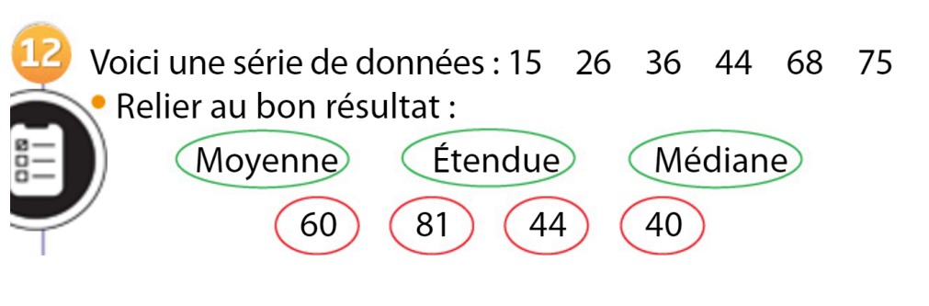

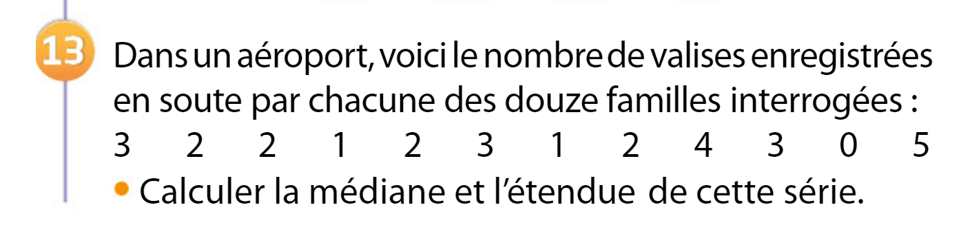

|  |  |  |  |  |  |
| --- | --- | --- | --- | --- | --- |
| **Nombre de valises** |  |  |  |  |  |
| **Effectifs** |  |  |  |  |  |